

Creating Modules in Puppet
DevOps Certification Training

support@intellipaat.com
+91-7022374614
US: 1-800-216-8930(Toll Free)

CREATING MODULES IN PUPPET
Steps for Puppet Master

Step 1: Create a new directory “new”, followed by the below command. Enter the required values and proceed
$ mkdir new
$ cd new
$ sudo puppet module generate intelli-new

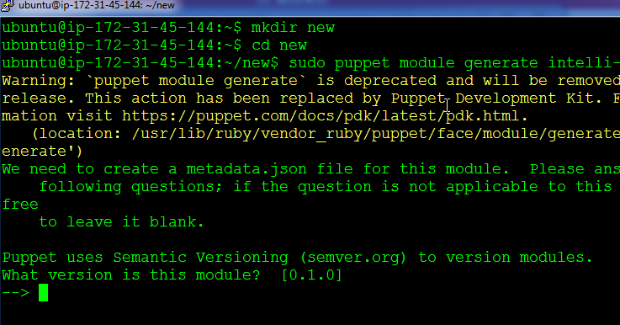

Step 2: You have successfully created the module. Change into the following directory ./new/new/manifests
Enter the following code in init.pp
class new{
file{'/tmp/module_test.txt':
content=> "This file is created by a module",
mode=> '0644',
}
}

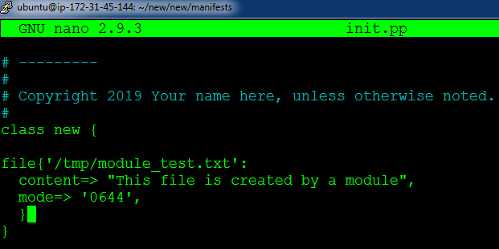

Step 3: Come back to the /new directory, and pass the following command:
$ sudo puppet module build new

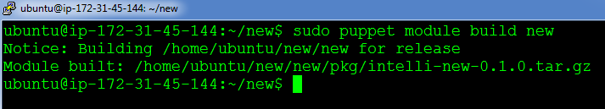

Step 4: Next, we will install the module by referring the tar.gz file from the last output:
$ sudo puppet module install ./new/pkg/intelli-new-0.1.0.tar.gz

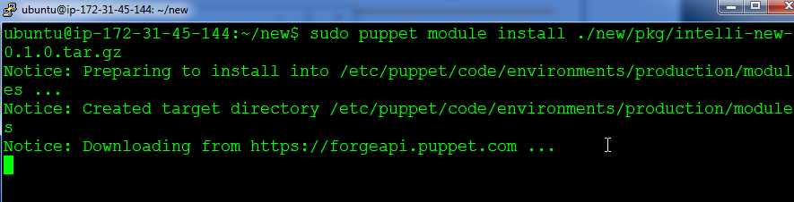

Step 5: Finally, go to the main manifest file in /etc/puppet/code/environments/production/manifest/site.pp
Finally, include the following code:

node default{
include new
}

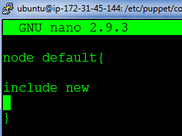
On Puppet Agent
Step 1: Execute the following command:
$ sudo puppet agent --test

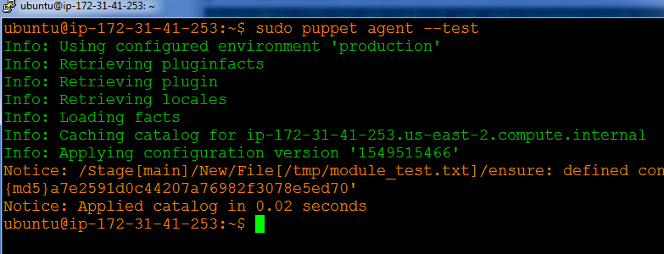

Step 2: Verify the configuration change by checking /tmp/module_test.txt
